Part2-Assignment-2: Spring MVC and Security

1. The program uses a databases named **mcvdb** I created with MySql server(**User : root and password:** ), similar to the one on the model you provided in the assignment . we one table **book**. the schema is the same on the assignment. I copied the one on the document

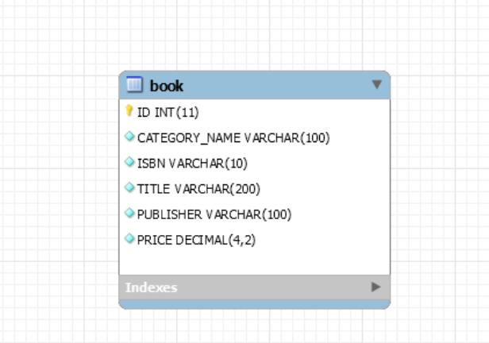

1. I created my project using the source code of part2-assignment1 spring-mvc-webbapp-1 in which I added the securities features and the delete book functionality.
2. I created the folder **main\resources\META-INF\sql** where I put my **shema.sql** corresponding to my database shema and **test-data.sql** to insert some data; the select * from book shows the following result

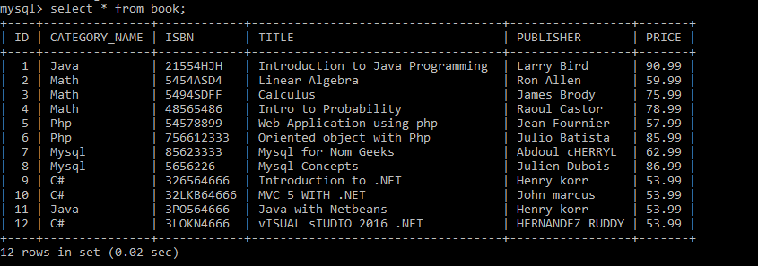

1. Configuring the Spring-mvc-webbapp-2 security

* I added a new Controller **SecurityController.java** in the controller package in which I handled the login fail.
* I added the file **security-context.xml** in which I defined the authentication manager. I created a **username:user** and **password: user** for testing purpose**.**
* I imported the **security-context.xml** into the **root-context.xml**.

1. Adding the Login functionality to the spring-mvc-webbapp-2 application

* In the header.jspx , I make sure only a logged user can create a new book or see the **update book** or **Delete book**
* I used **user/user** as username/password for testing purpose
* I added the login form in the menu.jspx

After building and deploying My application, I tested the login functionality. Those are the result bellow:

* I entered a wrong username and password

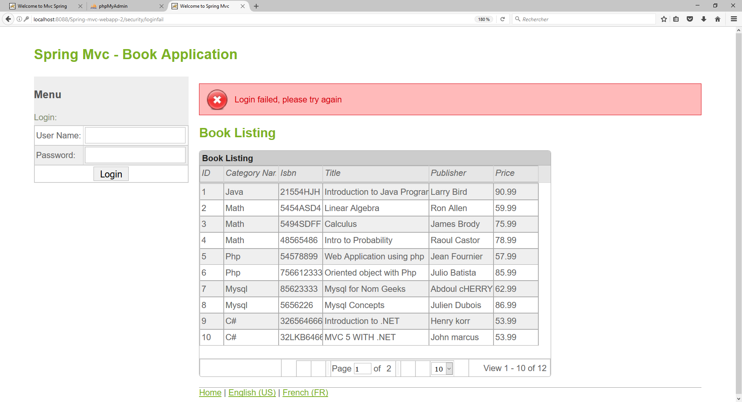

* Now I entered the good username and password user/user and I don’t see the login failure anymore and I have the welcome and logout link available.

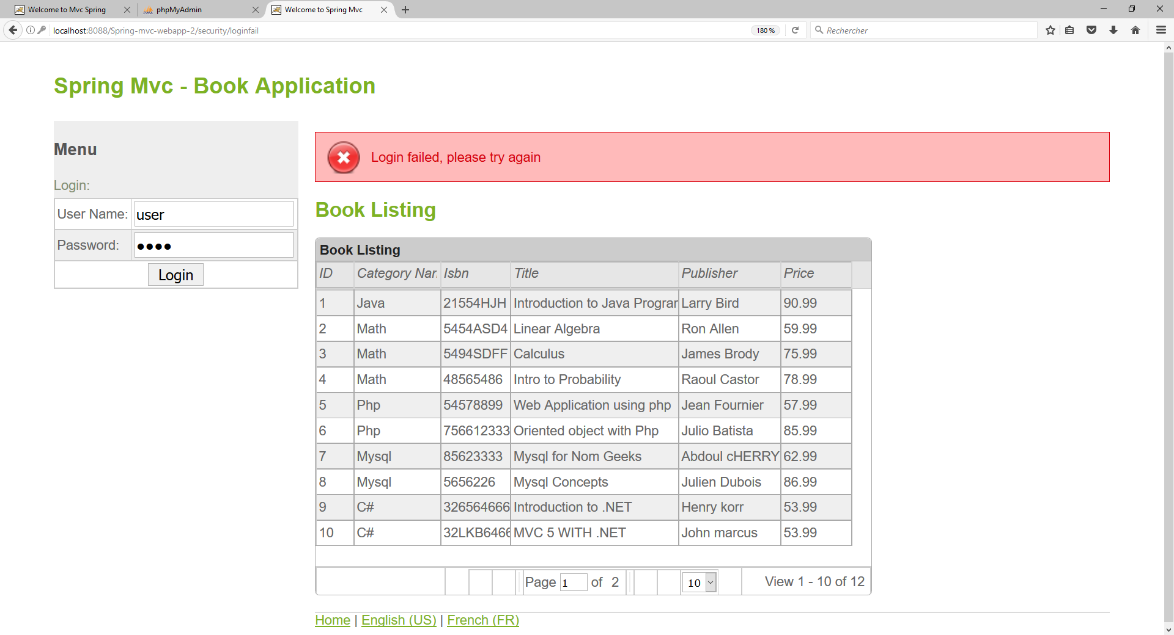

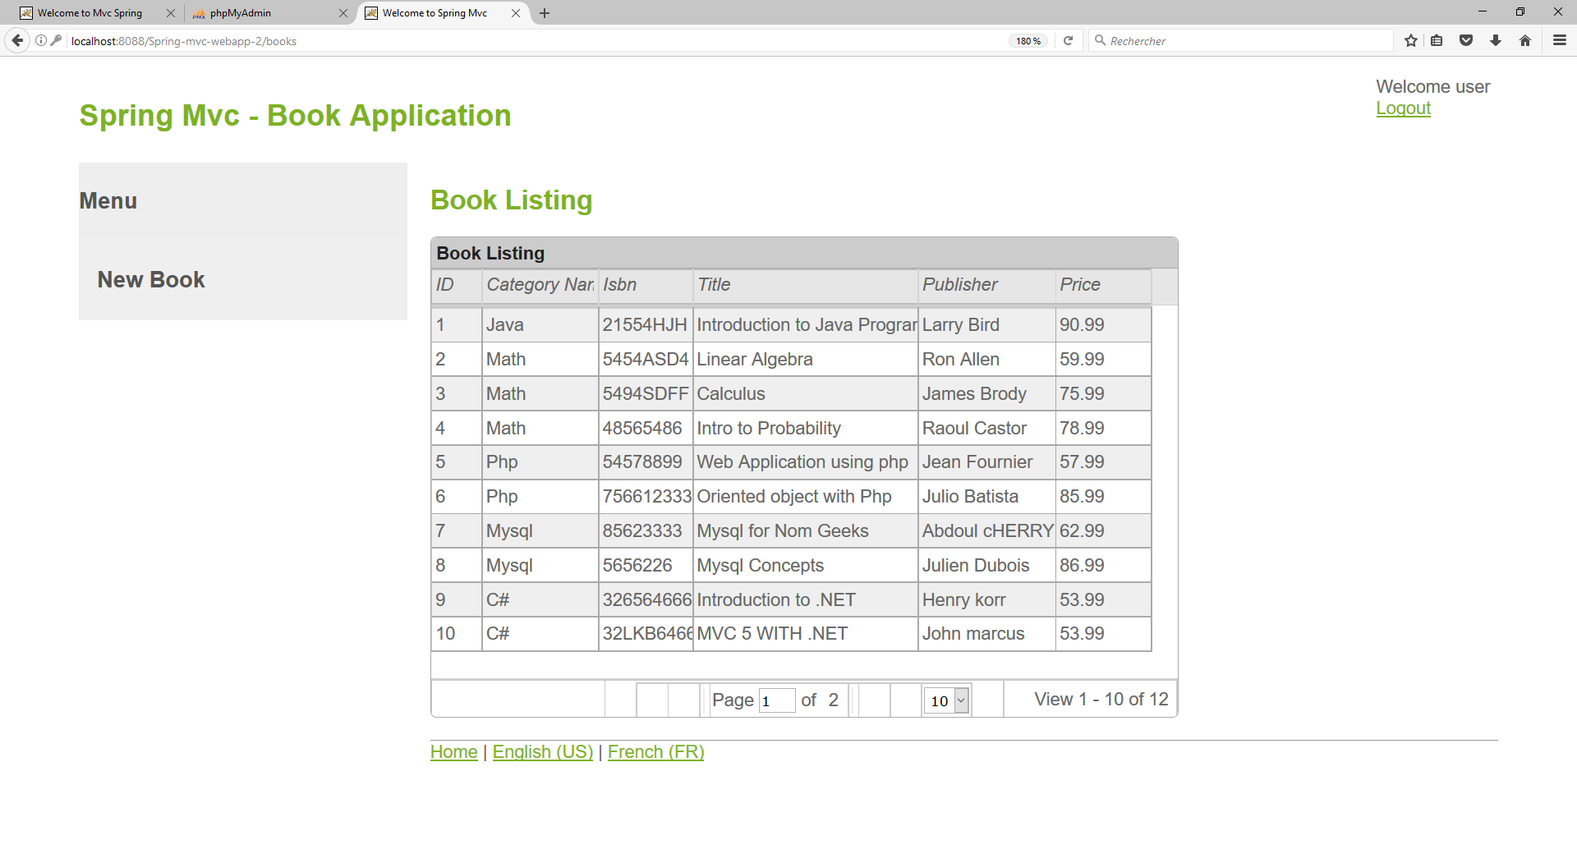

* After being logged in, I clicked the book with ID = 4 and got this Book Information dialog, I can see the **Update Book** and **Delete Book** link:

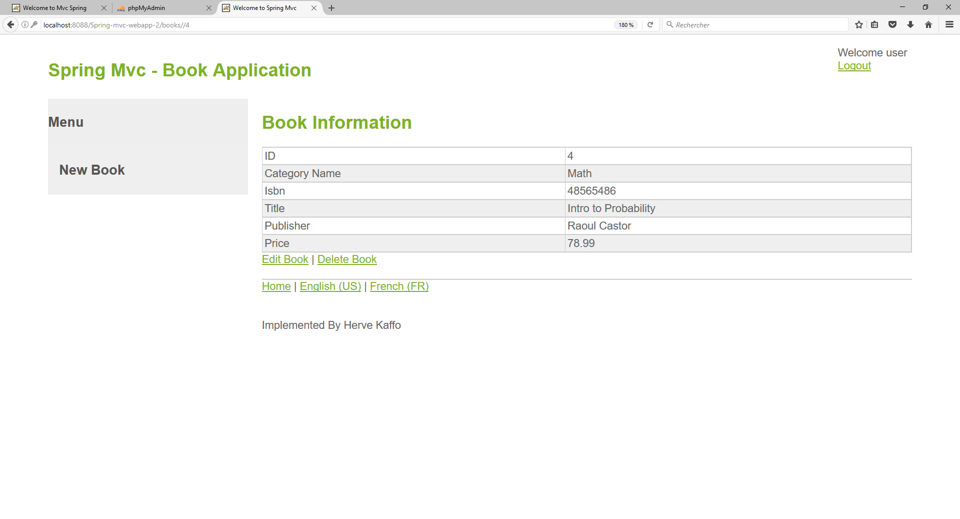

I can see the **Update Book** and **Delete Book** link:

* If I click the same book without getting logged in, I can’t see the **Update Book** and **Delete Book** link:

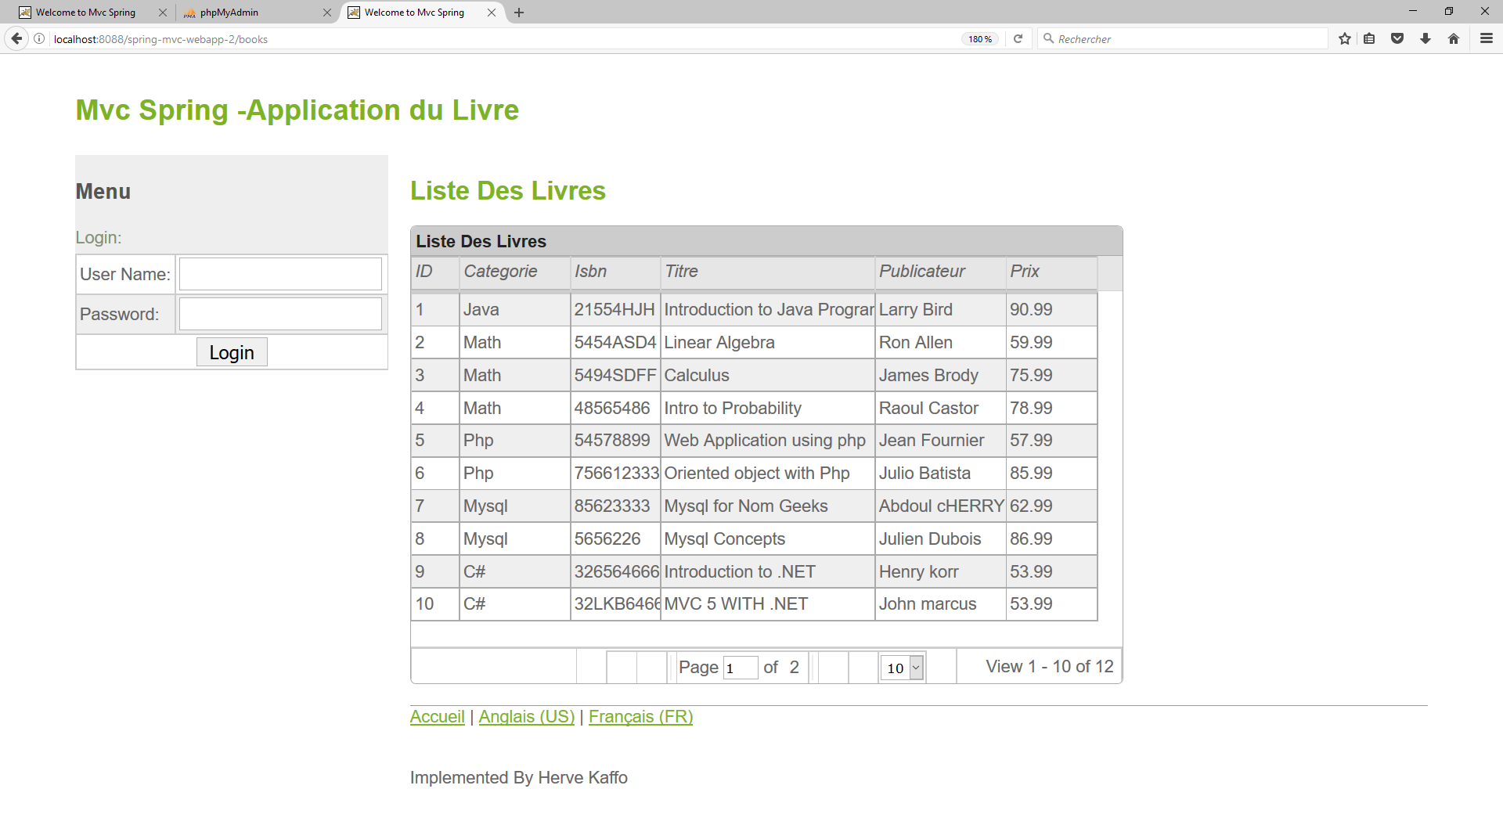

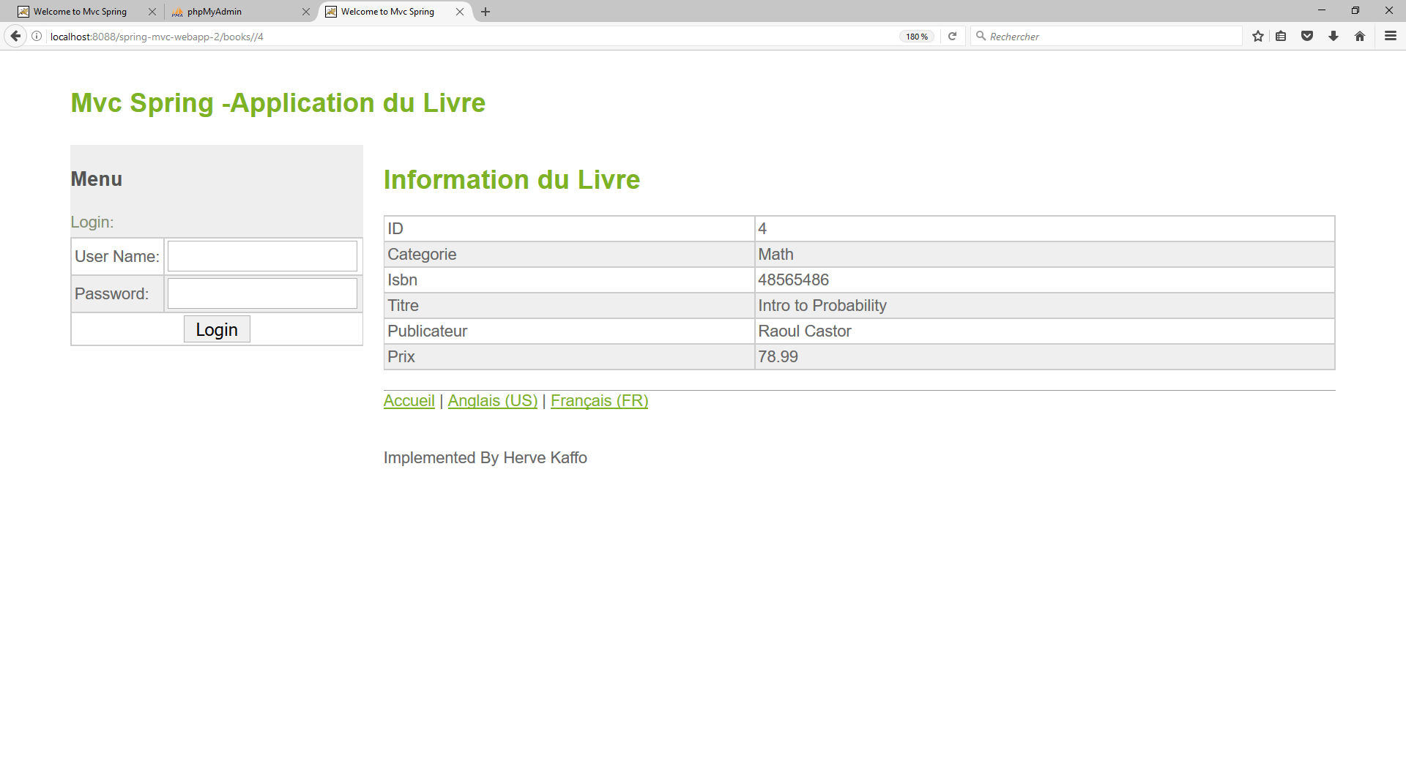

* Now if I’m logged and I click the new book link , I can add a book .

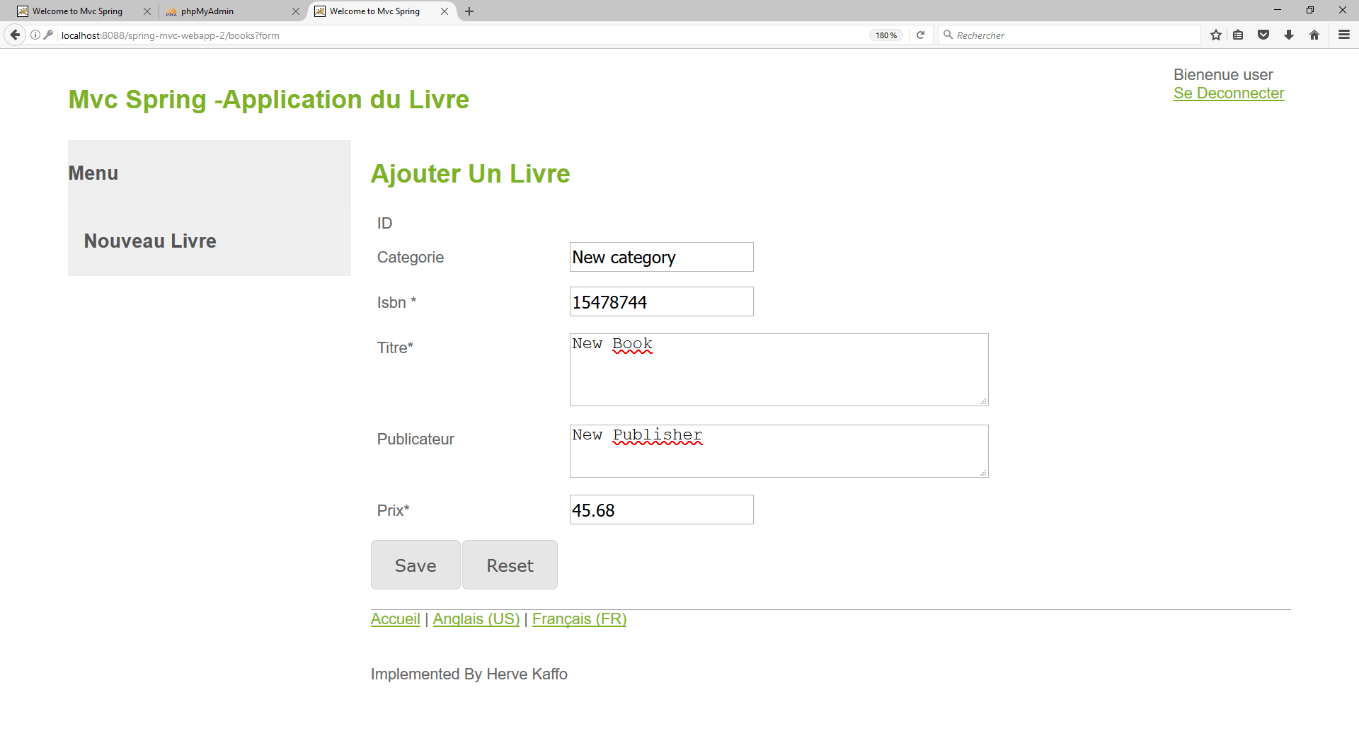

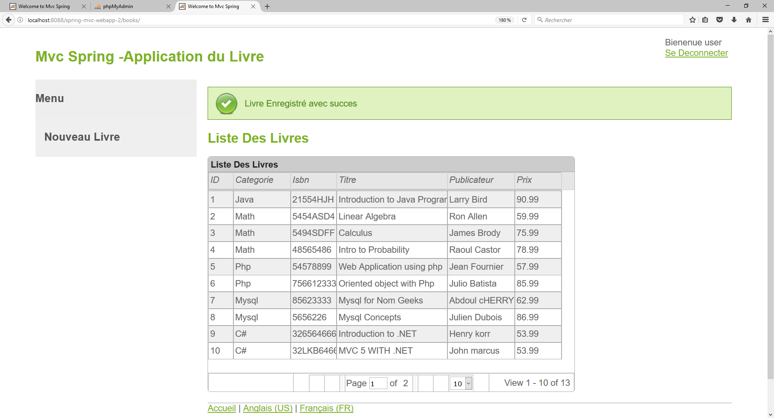

* I can see the new book inside the database

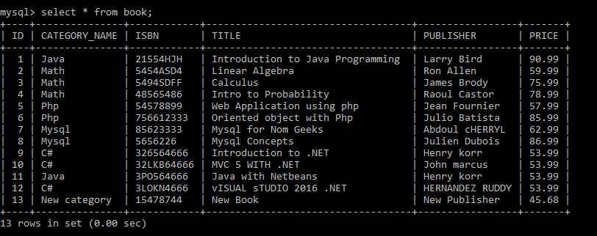

* I can also delete the book I just added.

I first select the book

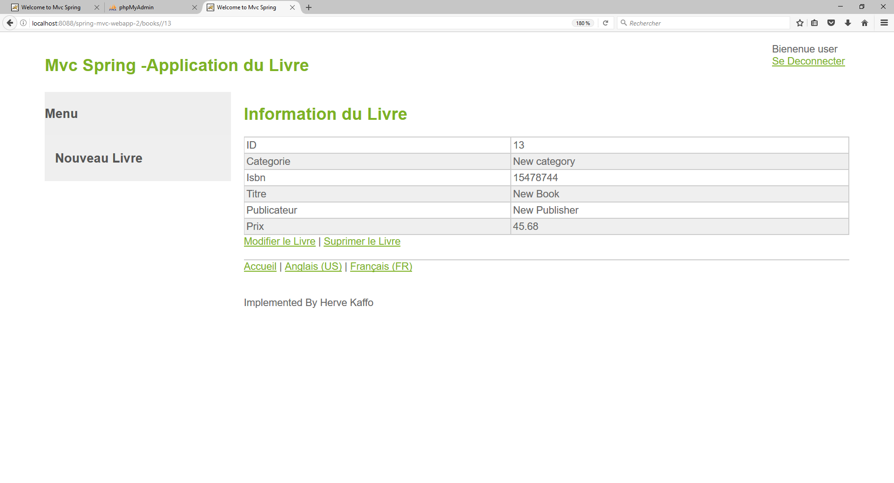

When I click the delete Book link, I have the following result:

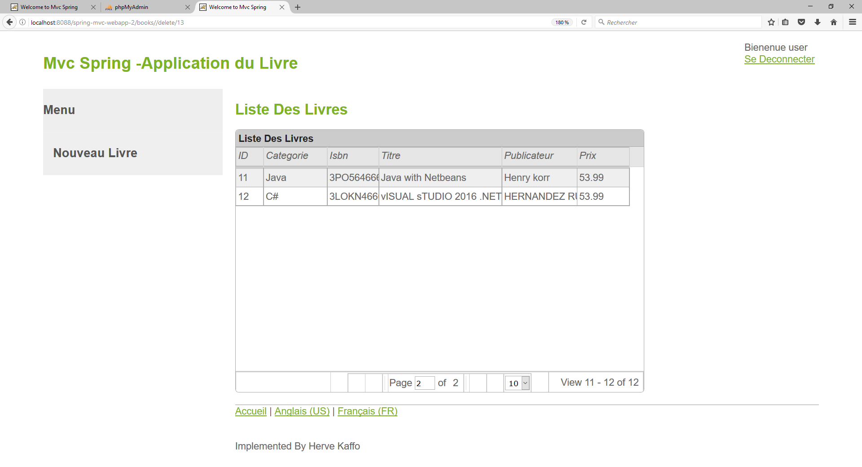

And the book is not in the database anymore

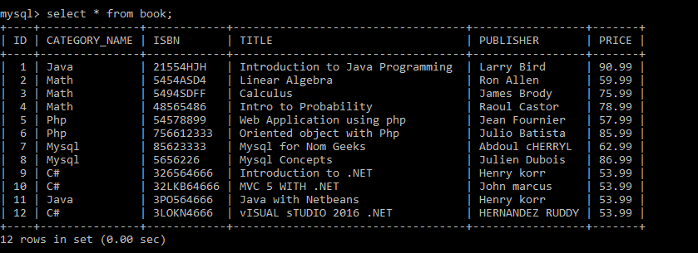

* **Using Annotations to Secure Controller Methods**
* url access :

I added the **<annotation-driven validator="validator"/> and <security:global-method-security pre-post-annotations="enabled"/>** in the **servelet-context.xml** and the annotation **@PreAuthorize("isAuthenticated()")** to the appropriate methods on the **BookController.java,**

I have the following result.

When I enter the URL <http://localhost:8088/spring-mvc-webapp-2/books?form> I have the following result

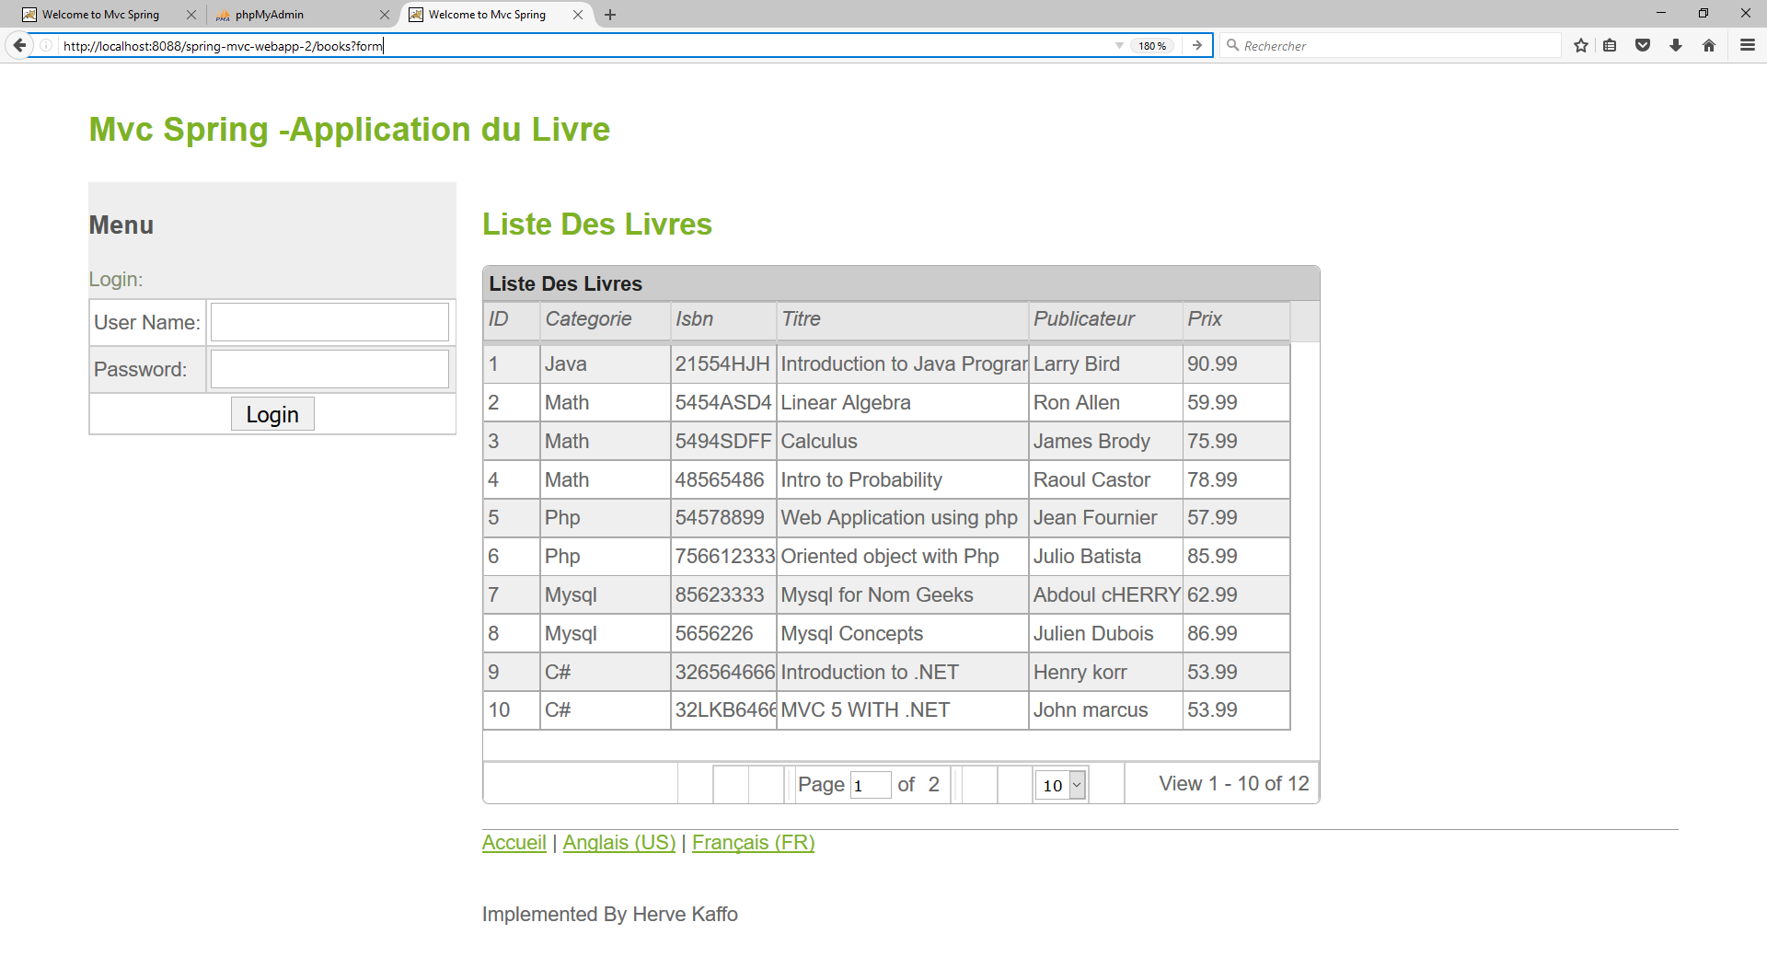

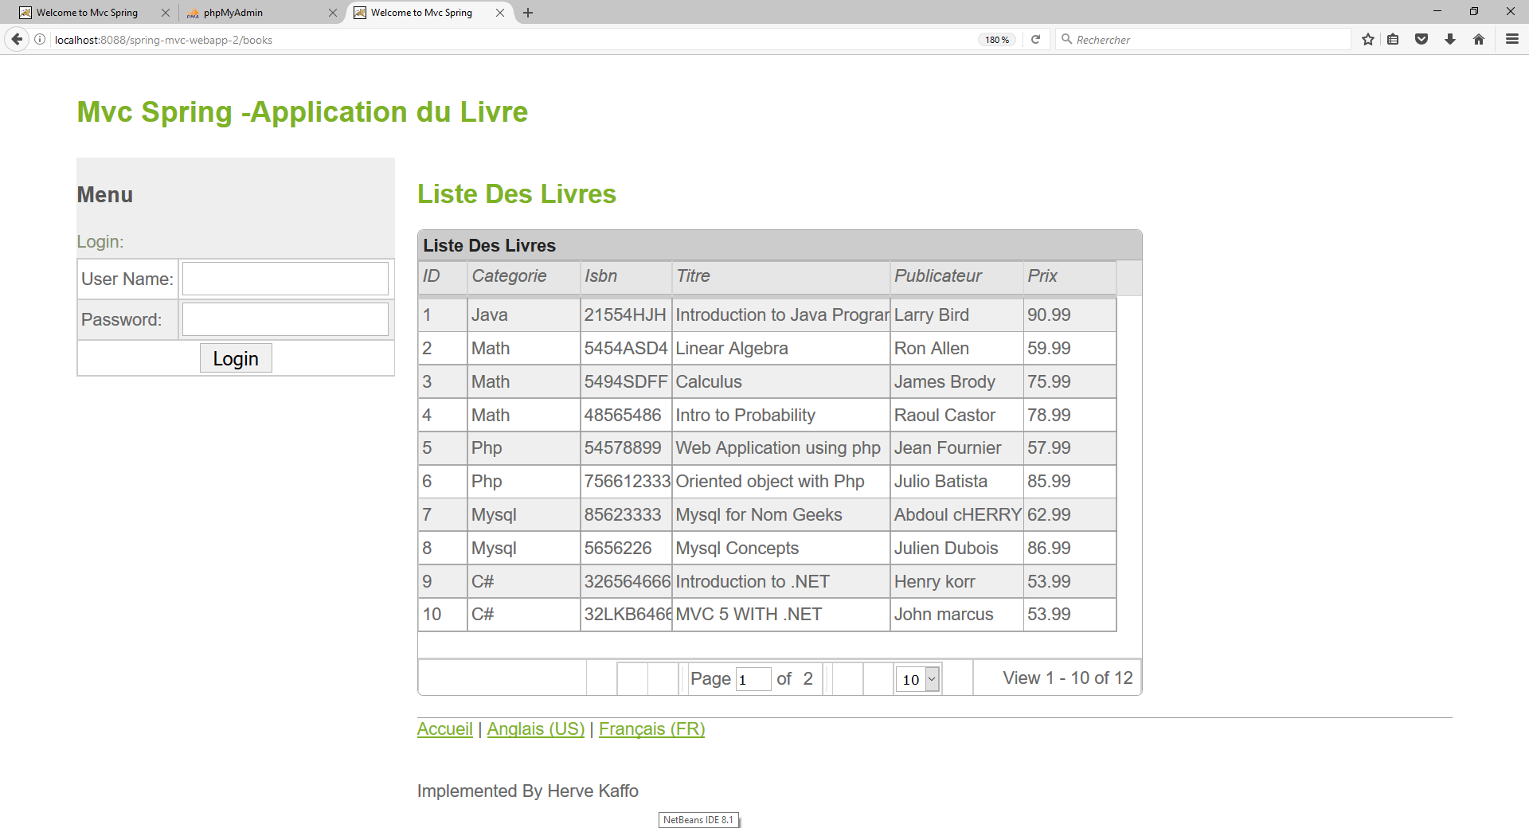

I got redirected to the home login page.

* At anytime of the application, if I click the logout link, I got redirected to the home login page :

